第⼆次作业报告

姓名：艾再提艾力·米吉提 学号：3017218180

实验⽬的

为图像加上⾼斯噪声和椒盐噪声，再分别实现多种均值滤波器、统计排序滤波器和⾃适应滤波器对 加了噪⾳后的图⽚进⾏还原处理，分析结果

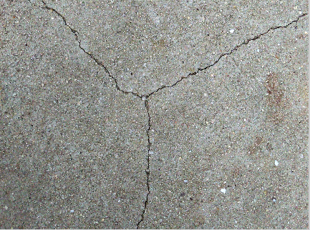实验过程

原图

⾸先调⽤加噪⾳函数为图⽚分别加⾼斯噪声和椒盐噪声

import numpy as np

import cv2

from numpy import shape

import random

from skimage.util import random_noise

from skimage import io

from tkinter import *

img = io.imread('1.JPG')

#⾼斯噪声

gauss_img = random_noise(img,mode='gaussian',seed=5000)

io.imsave('gauss_1.JPG',gauss_img)

#椒盐噪声

impulse_img = random_noise(img,mode='salt',seed=5000)

io.imsave('impulse_1.JPG',impulse_img)

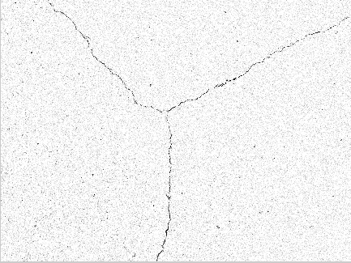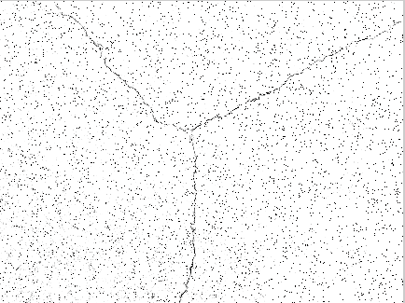

加入高斯噪声后的图像 加入椒盐噪声后的图像

处理图⽚，⽣成定义滤波器，分别对gauss加噪声和椒盐加噪声后图⽚进⾏处理

def deal_image(path):

image = io.imread(path, as_gray= True)

med_img = io.imread(path, as_gray= True) #中值滤波

geometry_img = io.imread(path, as_gray= True) #⼏何均值滤波

mean_img = io.imread(path, as_gray= True) #算数均值滤波

max_img = io.imread(path, as_gray= True) #最⼤值滤波

min_img = io.imread(path, as_gray= True) #最⼩值滤波

mid_pot_img = io.imread(path, as_gray= True) #中点滤波

arf_img = io.imread(path, as_gray= True) #修正后的阿尔法滤波

xb_img = io.imread(path, as_gray= True) #谐波滤波

back_xb_img = io.imread(path, as_gray=True) #反谐波滤波

for i in range(image.shape[0]):

for j in range(image.shape[1]):

med_img[i][j] = image[i][j]

geometry_img[i][j] = image[i][j]

mean_img[i][j] = image[i][j]

xb_img[i][j] = image[i][j]

back_xb_img[i][j] = image[i][j]

max_img[i][j] = image[i][j]

min_img[i][j] = image[i][j]

mid_pot_img[i][j] = image[i][j]

arf_img[i][j] = image[i][j]

return image, med_img, mean_img, geometry_img, xb_img, back_xb_img,

max_img, min_img, mid_pot_img, arf_img

#定义滤波器

image, med_img, mean_img, geometry_img, xb_img, back_xb_img, max_img,

min_img, mid_pot_img, arf_img = deal_image('impulse_1.JPG')#impulse_1.JPG

均值滤波器 均值滤波器都是使⽤3*3⼤⼩的滤波器⽤9个像素的均值代替中间的像素，⽤系数为1/mn(step)的 卷积模板来实现 实现算数均值滤波器

#算数均值滤波器

def mean_filter(x, y, step):

sum_s = 0

for k in range(-int(step / 2), int(step / 2) + 1):

for m in range(-int(step / 2), int(step / 2) + 1):

sum_s += image[x + k][y + m] / (step * step)

return sum_s

#⼏何均值滤波器

def geometry_filter(x, y, step):

sum_s = 0

for k in range(-int(step / 2), int(step / 2) + 1):

for m in range(-int(step / 2), int(step / 2) + 1):

sum_s *= image[x + k][y + m]

sum_r = sum_s ** (1/(step * step))

return sum_r

#谐波均值滤波器

def xb_filter(x, y, step):

sum_s = 0

for k in range(-int(step / 2), int(step / 2) + 1):

for m in range(-int(step / 2), int(step / 2) + 1):

sum_s += 1.0/image[x + k][y + m]

sum_r = (step*step) / sum_s

return sum_r

#逆谐波均值滤波器

def back_xb_filter(x, y, step):

sum_s = 0

q = 1.5

for k in range(-int(step / 2), int(step / 2) + 1):

for m in range(-int(step / 2), int(step / 2) + 1):

sum_s += image[x + k][y + m] / (step * step)

sum_r = (sum_s ** (q+1)) / (sum_s ** q)

return sum_r

统计排序滤波器

中值滤波器：最著名的顺序统计滤波器是中值滤波器，⽤该像素的相邻像素的灰度中值来替代该像素的值

#中值滤波器

def med_filter(x, y, step):

sum_s = []

for k in range(-int(step / 2), int(step / 2) + 1):

for m in range(-int(step / 2), int(step / 2) + 1):

sum_s.append(image[x + k][y + m])

sum_s.sort()

return sum_s[(int(step * step / 2) + 1)]

#最⼤值滤波器

def max_filter(x, y, step):

sum_s = []

for k in range(-int(step / 2), int(step / 2) + 1):

for m in range(-int(step / 2), int(step / 2) + 1):

sum_s.append(image[x + k][y + m])

sum_s.sort()

return max(sum_s)

#最⼩值滤波器

def min_filter(x, y, step):

sum_s = []

for k in range(-int(step / 2), int(step / 2) + 1):

for m in range(-int(step / 2), int(step / 2) + 1):

sum_s.append(image[x + k][y + m])

sum_s.sort()

return min(sum_s)

#中点滤波器

def mid_pot_filter(x, y, step):

return 0.5 * (max_filter(x, y, step) + min_filter(x, y, step))

# Step为滤波器的⼤⼩ 3*3

def test(Step):

for i in range(int(Step / 2), image.shape[0] - int(Step / 2)):

for j in range(int(Step / 2), image.shape[1] - int(Step / 2)):

med_img[i][j] = med_filter(i, j, Step)

mean_img[i][j] = mean_filter(i, j, Step)

geometry_img[i][j] = mean_filter(i,j,Step)

xb_img[i][j] = xb_filter(i, j, Step)

back_xb_img[i][j] = back_xb_filter(i, j, Step)

max_img[i][j] = max_filter(i, j, Step)

min_img[i][j] = min_filter(i, j, Step)

mid_pot_img[i][j] = mid_pot_filter(i,j,Step)

arf_img[i][j] = arf_filter(i, j, Step)

io.imsave(str(Step) + 'impulse_med.jpg', med_img)

io.imsave(str(Step) + 'impulse_mean.jpg', mean_img)

io.imsave(str(Step) + 'impulse_geometry.jpg', geometry_img)

io.imsave(str(Step) + 'impulse_xb.jpg', xb_img)

io.imsave(str(Step) + 'impulse_back_xb.jpg', back_xb_img)

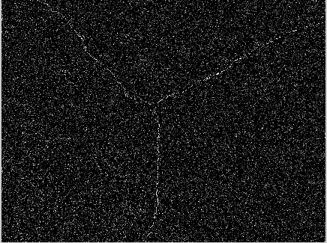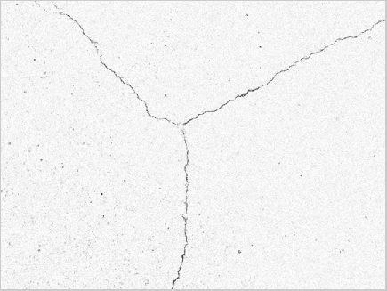

均值滤波图像 拉普拉斯滤波图像

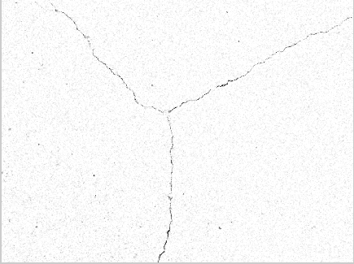

中值滤波图像

将加入椒盐噪声后的图像分别进行均值滤波、拉普拉斯滤波和中值滤波。，程序和上述程序类似，滤波后的结果如图

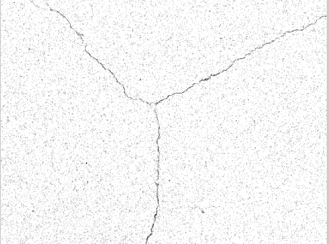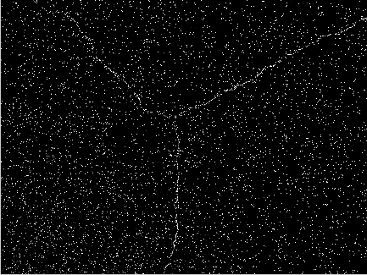

均值滤波图像 拉普拉斯滤波图像

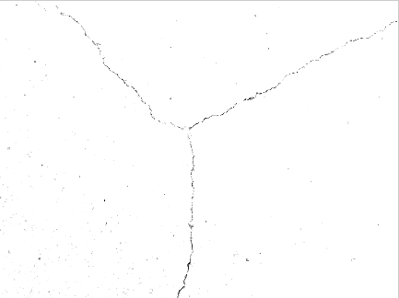

中值滤波图像